**NOTE: This is an official document by Indexademics. Unless otherwise stated, this document may not be accredited to individuals or groups other than the club IDX, nor should this document be distributed, sold, or modified for personal use in any way.**

**IDX G9 PHYSICS H STUDY GUIDE ISSUE 3**

**By Ivan**

**4.7 -4.8 Solving Problems with Newton’s Laws**

* Newton’s First Law: An object at rest stays at rest and an object in motion stays in motion with the same speed and in the same direction unless acted upon by an unbalanced force.
* Newton’s Second Law: The acceleration of an object is directly proportional to the net force acting on it and inversely proportional to its mass $F_{net}=ma$.
* Newton’s Third Law: For every action, there is an equal and opposite reaction.
* Friction: $F_{fs}≤μ_{s}F_{N}$, $F_{fk}=μ_{k}F_{N}$
* Translational equilibrium: If the net force on an object is zero, then the object is in translational equilibrium.
  + Two types: object at rest, and object moving at constant velocity
  + The net sum of forces is 0: $\sum_{i}{F_{i}=0}$.
  + 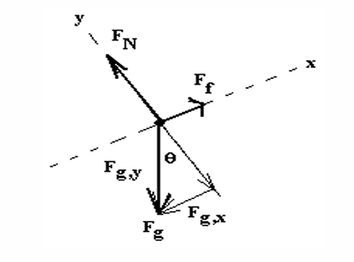Ex.The forces on an inclined plane are decomposed into: 1) perpendicular to inclined plane, 2) parallel to inclined plane:

Formula: $F_{gx}=mg sin θ$, $F_{gy}=mg cos θ$, convenient equation:

* + 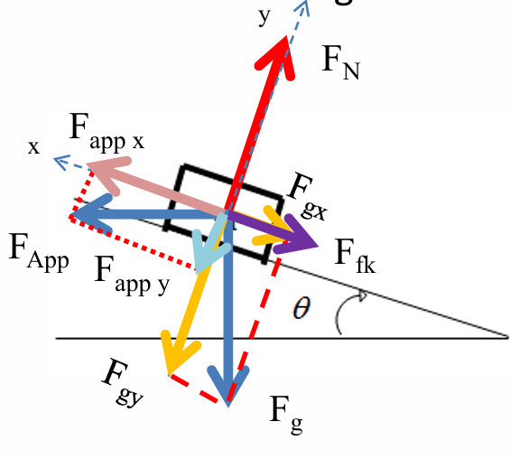Inclined plane involving applied force:

Equations: $F_{N}=mgsinθ-F_{app}sinθ$, $mgsinθ=F_{app}cosθ-μmgsinθ+{μF}_{app}sinθ$

Essential method for inclined planes:

1. Decompose the gravity and applied force perpendicular to the inclined plane to obtain the normal force
2. Use the normal force to yield the friction
3. Resolve the equilibrium with the forces parallel to the plane, gravity and friction

* Connected Bodies
  + System: any group of one or more objects we choose to consider and study
  + External force: Any force on a system from a body outside of the system
  + Internal force: Force between bodies of a system
  + By using the idea of connected bodies, we consider a system of objects with the **same acceleration** as one object, such that the internal forces (such as tension and normal force) between them need not to be considered.
  + Generally, the acceleration is the net force divided by the mass of the objects $a=\frac{\sum_{i}{F_{i}}}{\sum_{i}{m_{i}}}$
  + The tension force is then the resistance force and the force on an object, such that in the system the tension force cancels out the resistance force for the net force.
  + 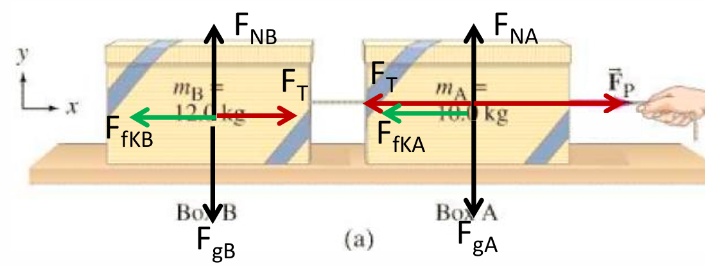Ex. Two boxes connected with a string and pulled at one end by a force

Net force: $F_{net}=F_{P}-F_{f}=Ma$

Net acceleration: $a= \frac{F_{net}}{m_{A}+m_{B}}$

Tension force:

* + 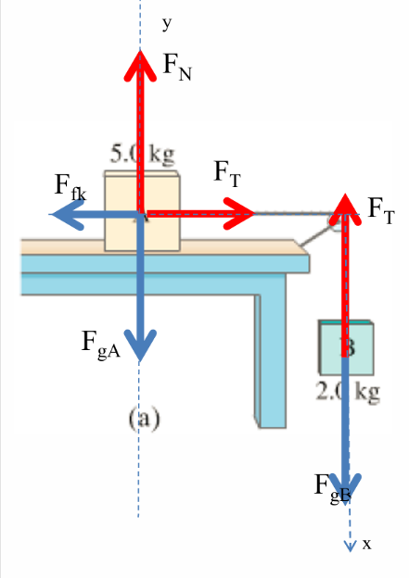Ex. Two boxes connected with a rope on a pulley

Net force: $F_{net}=F_{gB}-F_{fkA}$

Tension force:

* + 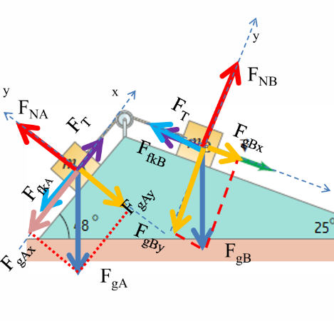Ex. Two connected boxes on a ramp (direction of motion can be obtained from net force)

Net Force: $F_{net}=F_{gBx}-F_{fkB}-F_{gAx}-F_{fkA}$

Tension Force: for B $F_{T}=F_{netB}-F_{gBx}+F_{fkB}$, or for A $F_{T}=F_{netA}+F_{gAx}+F_{fkA}$

**1.4-1.7 Measurement and Estimating**

* A measurement is a comparison between an unknown quantity and a standard
* Significant Digits: the valid/reliable digits in a measurement
  + Last digit in a measurement is an estimated/uncertain digit
  + Counting Significant Digits:
    1. All non-zero digits and any zeros contained between non-zero digits (6 s.f. in 300042)
    2. Exact numbers and constants have infinite significant digits ( $∞$ s.f. in $π$)
    3. Trailing zeros if there is a decimal point (3 s.f. in 200.)
    4. Trailing zeros do not count unless scientific notation is explicitly used (3 s.f. in 2990 while 4 s.f. in $2.990×{10}^{3}$)
  + Addition and Subtraction: round the result to have as many decimal places as the measured number with the smallest number of decimal places.
  + Multiplication and Division: round the result to have as many s.f. as the measured number with the smallest number of s.f..
* Uncertainty: the variation in measured data
  + Systematic Error: consistent or reproducible error that affects the accuracy of a measurement. Caused by instrument, environment, or methodology
  + Random Error: an unpredictable variation in measurements. Caused by human or environment fluctuations
  + Accuracy: how close a measurement is to the accepted value
  + Precision: the repeatability of the measurement using a given instrument (number of s.f.)
  + Instrument Limit of Error (ILE): the maximum amount by which a measurement made by an instrument can deviate from the true value. Generally least count of 1/2 of least count
  + Deviation: the amount by which a single value differs from the average
  + Representing Experimental Result: $x±Δx$
    1. Absolute uncertainty/error: $Δx$
    2. Relative uncertainty: $\frac{Δx}{x}$
    3. Relative Error: (measured value – expected value) / expected value
    4. Percentage uncertainty/error: relative uncertainty $×100\%$
* Error Propagation
  + Addition and Subtraction: $\left(A±ΔA\right)±\left(B±ΔB\right)=(A±B)±(ΔA+ΔB)$
  + Multiplication and Division: $\left(A±ΔA\right)×\left(B±ΔB\right)=\left(A×B\right)±\left(A×B\right)×(\frac{ΔA}{A}+\frac{ΔB}{B})$ $\frac{\left(A±ΔA\right)}{\left(B±ΔB\right)}=\left(\frac{A}{B}\right)±\left(\frac{A}{B}\right)×(\frac{ΔA}{A}+\frac{ΔB}{B})$
  + For multiplication by an exact number, multiply the uncertainty by the same exact number
  + Powers: for $x=Ay^{a}z^{b}$, $\frac{Δx}{x}=\left|a\right|\frac{Δy}{y}+|b|\frac{Δz}{z}$
* Graphing Data
  + Variables: independent and dependent variable
    1. Choose simple scales
    2. Plot the points neatly
    3. Draw a best fit line through the data if they form a straight line
    4. Draw a best fit curve if they form a curve
    5. Check the data if it is anomalous, or just ignore
    6. Draw error bars for the data